LAB EXPERIMENT RECORD

Set 12: Website Traffic
Department | AIDS
Course Code / Course Name | DSA0602/ Data Handling and Visualization
Experiment | Data Visualization using R
Name | Ayesha Siddiqa S
Register Number | 192324305
Date | 06/10/2026
Day | Wednesday

AIM
To analyze website traffic data using R and Tableau by creating a line chart for daily page views, a bar chart for the top days based on click-through rate, a data table, and an interactive dashboard.

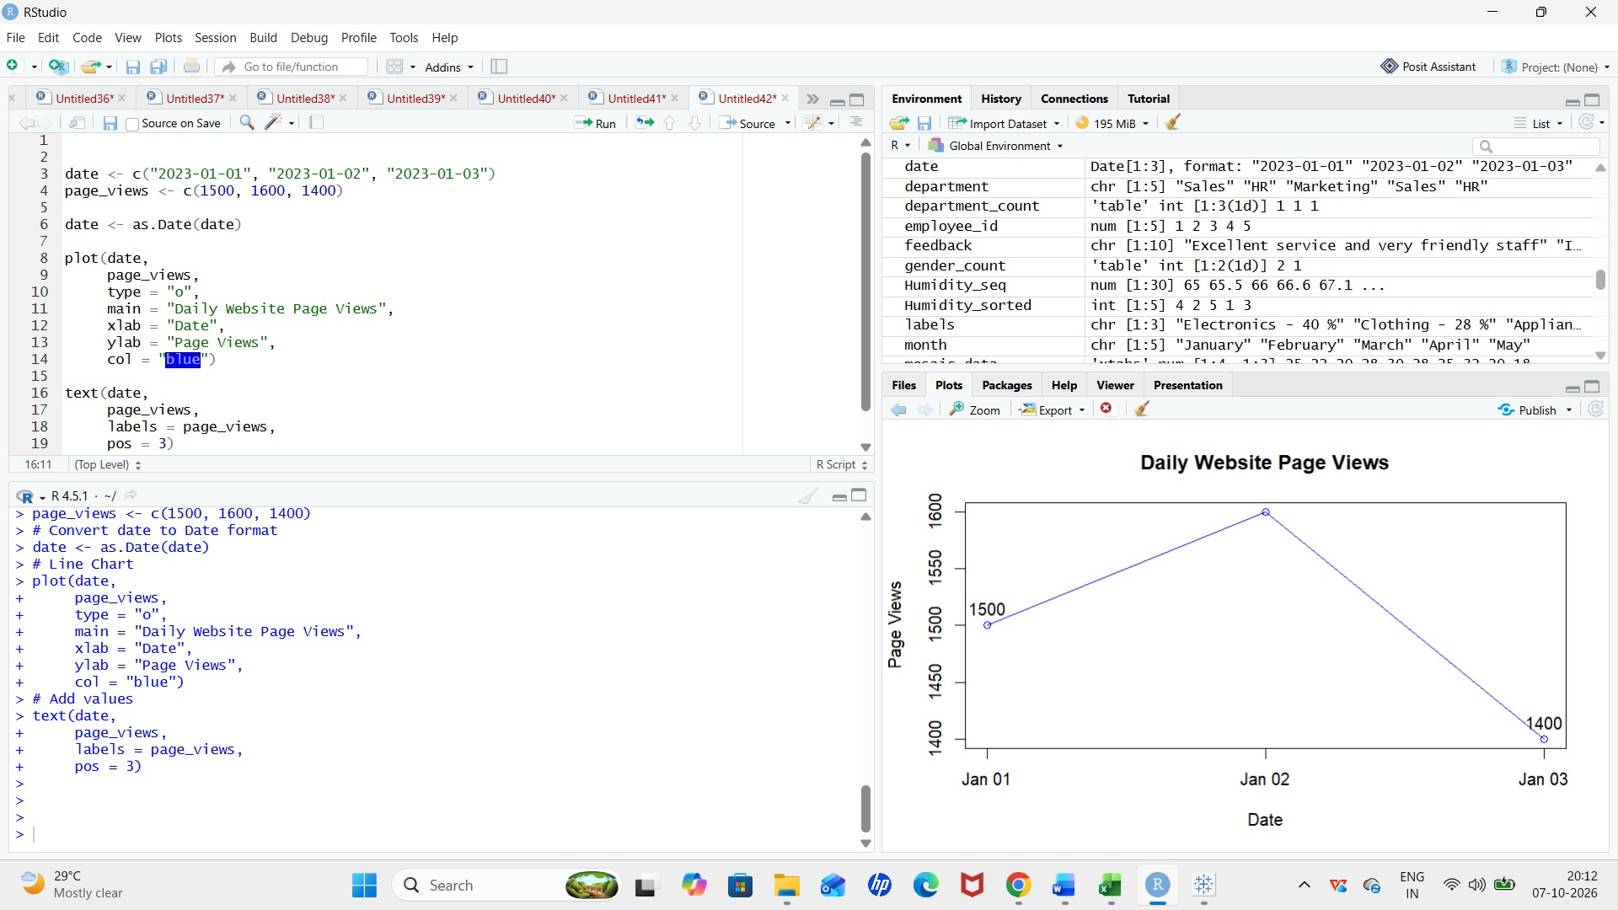
- Create a line chart to visualize the trend in daily page views over time.


date <- c("2023-01-01", "2023-01-02", "2023-01-03")
page_views <- c(1500, 1600, 1400) date <- as.Date(date)
plot(date, page_views, type = "o",
main = "Daily Website Page Views", xlab = "Date",
ylab = "Page Views", col = "blue")
text(date, page_views,
labels = page_views, pos = 3)

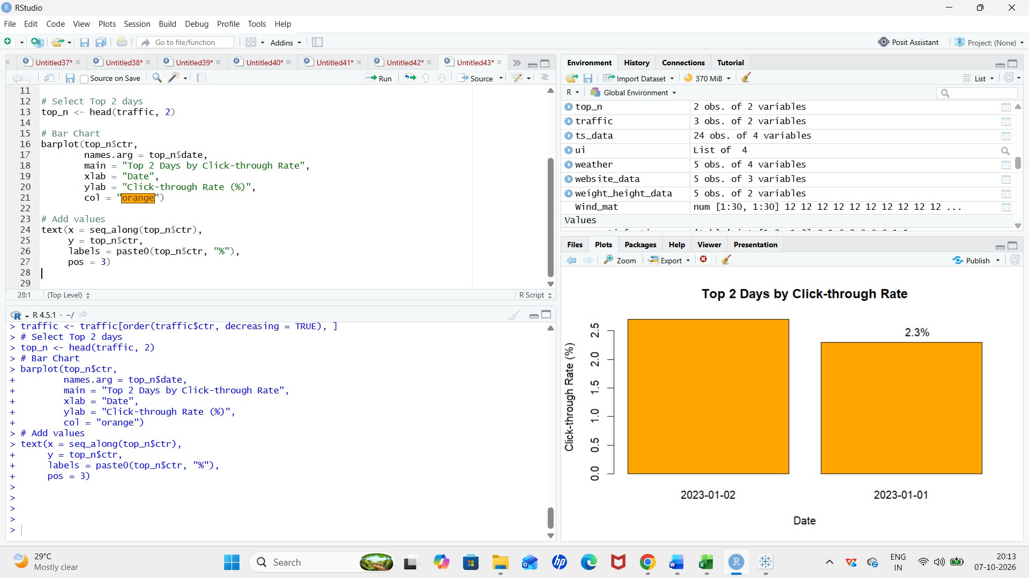
- Generate a bar chart showing the top N days with the highest click-through rates.


date <- c("2023-01-01", "2023-01-02", "2023-01-03")
ctr <- c(2.3, 2.7, 2.0)

traffic <- data.frame(date, ctr)

traffic <- traffic[order(traffic$ctr, decreasing = TRUE), ] top_n <- head(traffic, 2)
barplot(top_n$ctr,
names.arg = top_n$date,
main = "Top 2 Days by Click-through Rate", xlab = "Date",
ylab = "Click-through Rate (%)", col = "orange")

text(x = seq_along(top_n$ctr), y = top_n$ctr,
labels = paste0(top_n$ctr, "%"), pos = 3)

- Build a table to show the website traffic data for each day. Label the table elements.


traffic_data <- data.frame(
Date = as.Date(c("2023-01-01",
"2023-01-02",
"2023-01-03")),
Page_Views = c(1500, 1600, 1400),
Click_Through_Rate = c("2.3%", "2.7%", "2.0%")
)

print(traffic_data)

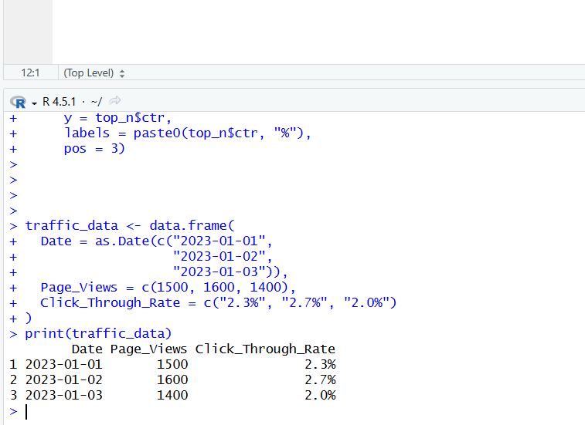

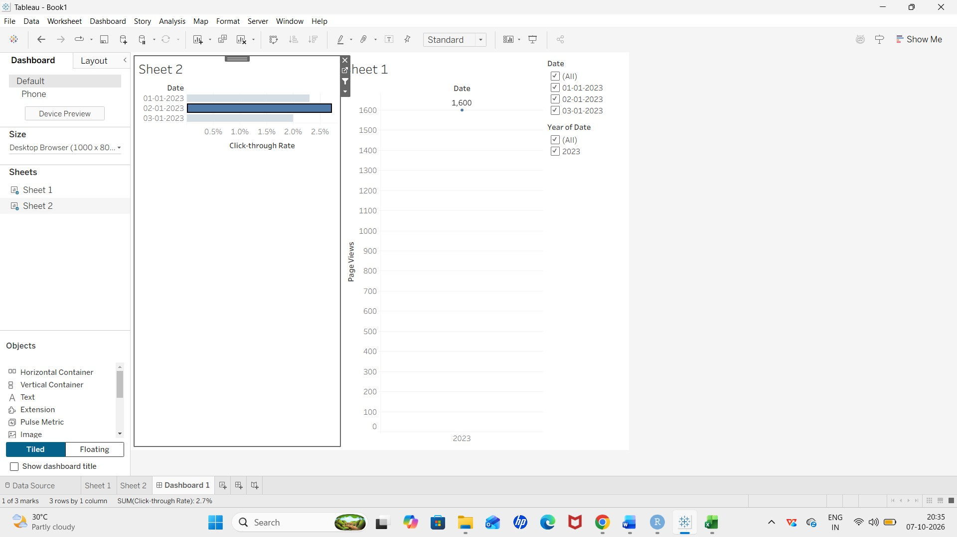

PROCEDURE

- Enter the website traffic data containing Date, Page Views, and Click-through Rate.

- Create a line chart to visualize the daily trend in page views.

- Create a bar chart to display the top days with the highest click-through rates.

- Create a table to display the website traffic details for each day.

- Import the dataset into Tableau.

- Create separate worksheets for the line chart, bar chart, and table.

- Combine all three worksheets into a Tableau dashboard.

- Add labels, titles, and filters to make the dashboard interactive.

RESULT

The website traffic data was successfully analyzed using R and Tableau. The line chart shows the daily page-view trend, the bar chart identifies the top days based on click-through rate, and the table displays the complete traffic data. An interactive Tableau dashboard was successfully developed by combining all three visualizations.

